Create HTML Pages

* We use HTML to create the front-end part of the web page.
* Here, we have created 3 HTML pages- home.html, image.html,imageprediction.html, and 0.html.
* home.html displays the home page.
* image.html is used for uploading the image
* imageprediction.html will showcase the output
* 0.html is to showcase the result. It tells the action to be performed on imageprediction.html while showcasing the result.

For more information regarding HTML <https://www.w3schools.com/html/>

* We also use JavaScript-main.js and CSS-main.css to enhance our functionality and view of HTML pages.

o Link [:CSS](https://www.w3schools.com/css/) , [JS](https://www.w3schools.com/js/DEFAULT.asp)

Home.html looks like this



image.html

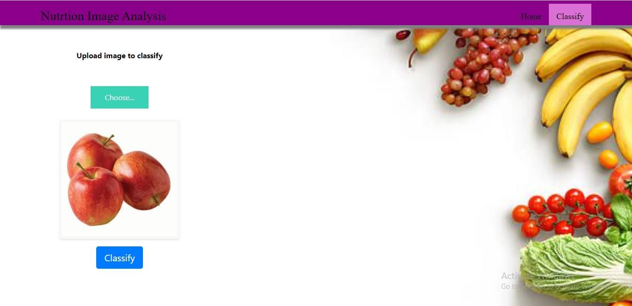

Imageprediction.html

